PROJECT: SMART LIBRARY REQUEST WORKFLOW USING SERVICENOW

TEAM MEMBERS :

Shalini.S

Nesapriya.M

Sandhiya.R

Sharmila.P

1. INTRODUCTION :

1.1 Project Overview :
Smart Library Request Workflow is a system developed to automate library service requests using the ServiceNow platform. In many educational institutions, library requests such as book requests, issue requests, or return requests are handled manually. This manual process can cause delays, errors, and difficulties in tracking requests.
The Smart Library Request Workflow system allows users to submit library requests through an online form. The request is automatically processed through ServiceNow workflows and stored in database tables. Library administrators can review, approve, or reject requests efficiently.
By automating the library request process, the system improves efficiency, reduces manual work, and ensures faster request handling.

1.2 Purpose :
The main purpose of this project is to automate the library request process using the ServiceNow platform. Instead of submitting requests manually, users can submit requests through an online form.
The system automatically processes the request through workflows and notifies the library administrator. This helps in reducing paperwork, improving request tracking, and providing faster service to students and staff.

2. IDEATION PHASE :

2.1 Problem Statement:
In many educational institutions, library requests such as borrowing books or requesting new books are managed manually through paper forms or direct communication with library staff. This manual process is time-consuming and difficult to track.
Students may face delays in getting approvals, and library staff may find it difficult to manage multiple requests efficiently.
Therefore, there is a need for an automated system that allows users to submit library requests online and enables library administrators to manage requests efficiently.
The Smart Library Request Workflow system solves this problem by automating the request process using the ServiceNow platform.

2.2 Empathy Map Canvas :
Users Do: Primary Users: Students and Library Staff
Users Think:
They want a simple system to request books easily.
Users Feel:
Manual request processes are slow and inconvenient.
Users Say:
They need a quick way to submit and track library requests.
Currently they submit requests manually or ask library staff directly.
The system is designed to improve the user experience by providing an automated request workflow.

2.3 Brainstorming :
During the brainstorming phase, several ideas were discussed to improve the library request process.
Ideas considered include:
• Creating an online library request form
• Automating request approval workflows
• Sending notifications for request status updates
• Creating a database to store request information
• Generating reports for library requests
After evaluating these ideas, the best solution was to develop a Smart Library Request Workflow using ServiceNow.

3. REQUIREMENT ANALYSIS :

3.1 Customer Journey Map :
- User logs into the ServiceNow platform.
- User opens the Smart Library Request application.
- User submits a book request through the form.
- The system stores the request in a ServiceNow table.
- The workflow sends the request to the library administrator.
- The administrator approves or rejects the request.
- The user receives a notification about the request status.

3.2 Solution Requirements :

Functional Requirements :
• The system should allow users to submit library requests.
• The system should store request details in a database table.
• The system should automate the approval workflow.
• The system should notify users about request status.
• The system should allow administrators to manage requests.

Non-Functional Requirements :
• The system should be user-friendly.
• The system should securely store request data.
• The system should provide reliable performance.

3.3 Data Flow Diagram :
Input:
User submits library request details through the form.
Process:
ServiceNow workflow processes the request and sends it to the administrator.
Storage:
Request information is stored in ServiceNow database tables.
Output:
Request approval/rejection and notification sent to the user.

3.4 Technology Stack :
Technology | Description
ServiceNow | Cloud platform used to develop the application
ServiceNow Tables | Used to store library request data
Forms | Used for submitting book requests
Flow Designer | Used to automate request workflows

4. PROJECT DESIGN :

4.1 Problem Solution Fit :
The Smart Library Request Workflow system solves the problem of manual library request management. Instead of paper-based requests, users can submit requests digitally through ServiceNow forms.
The system automatically processes requests using workflows and allows library administrators to manage them efficiently.

4.2 Proposed Solution :
The proposed solution is to develop a Smart Library Request Workflow system using the ServiceNow platform.
Users can submit library requests through a form, which is stored in a database table. Workflow automation processes the request and sends it to the library administrator for approval. Notifications are sent to users regarding the request status.
This automated system improves efficiency and reduces manual effort in managing library requests.

4.3 Solution Architecture :

5. ADVANTAGES & DISADVANTAGES :

Advantages :
• Automates library request process
• Reduces manual paperwork
• Faster request approval
• Easy tracking of request status
• Improves efficiency of library services

Disadvantages :
• Requires internet connectivity
• Initial system setup may require technical knowledge
• Depends on ServiceNow platform availability

6.SCREENCHOT :

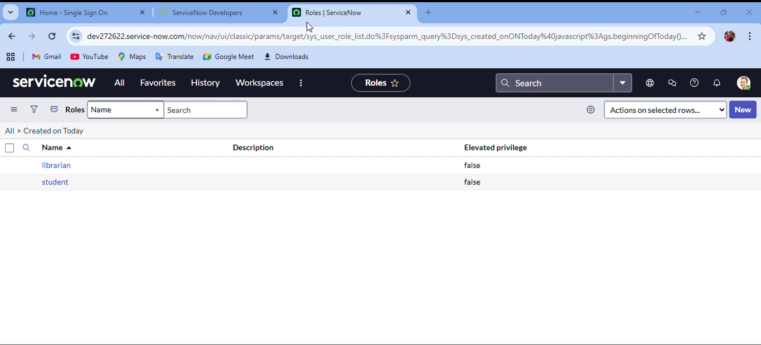

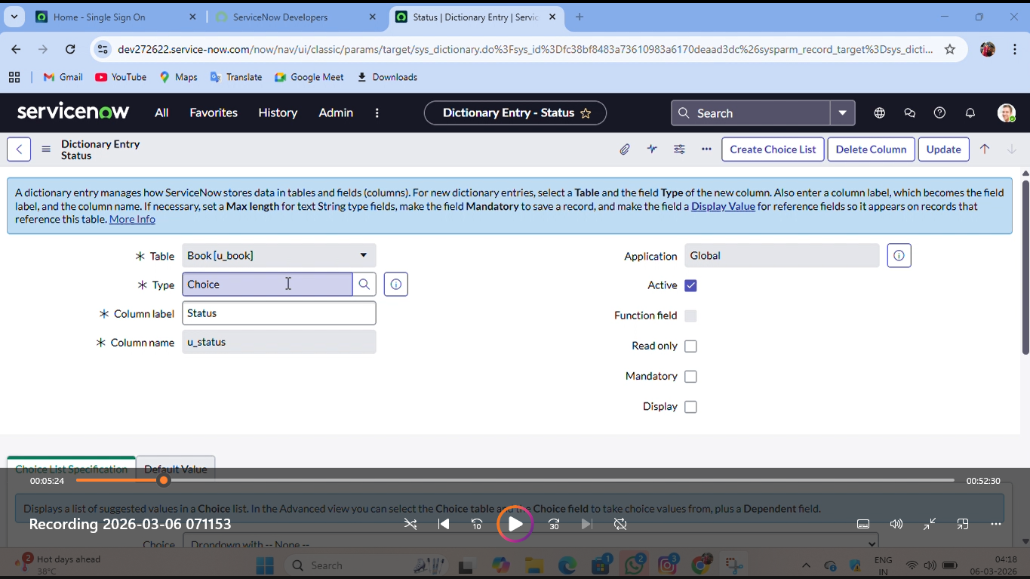

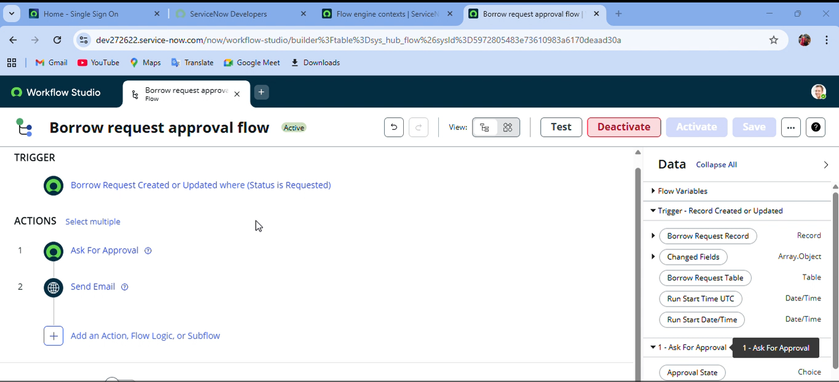

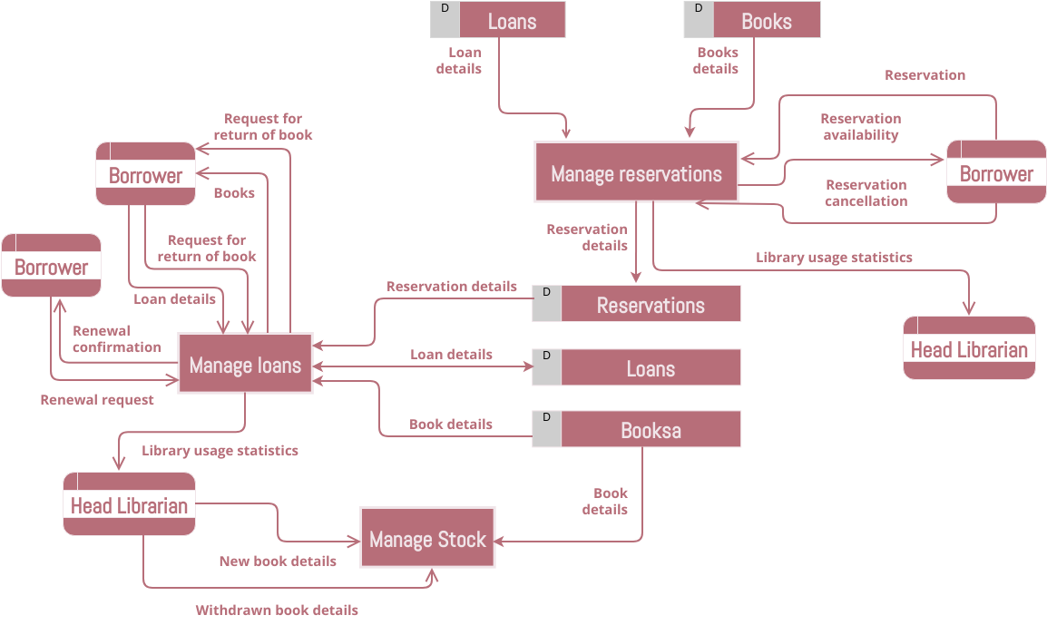

7. CONCLUSION :
The Smart Library Request Workflow system successfully demonstrates how ServiceNow automation can improve the efficiency of library request management. The system simplifies the process of submitting, processing, and approving library requests.
By automating the workflow, the system reduces manual effort, improves request tracking, and provides faster service to users.

8. FUTURE SCOPE :
The system can be enhanced with additional features such as:
• Book availability tracking
• Integration with digital library systems
• Automated book issue and return management
• Reporting and analytics for library usage
• Mobile application integration

